**DEVREV BACKEND TASK - 2 VACCINE APPLICATION (DEVELOPED AS FULL STACK APP)**

**NAME**: ABINANDAN.V

**EMAIL** : [abiz12391@gmail.com](mailto:abiz12391@gmail.com)

**MOBILE**: 8508000551

Code base Zip File Link: <https://drive.google.com/file/d/1YrJKQYJm0_lfkbusGMuEneqS0cN4YTrQ/view?usp=drive_link>

GITHUB Repo Link: <https://github.com/Abinandan314/vaccine-application>

**Tech Stack Used:**

1. Backend - Java, Spring Boot
2. Database - MongodB
3. Frontend - React JS

**Running the application**

* Clone the repository: git clone <repository-url>
* Navigate to the project directory: cd vaccine-application/vaccineApplication-frontend
* Install dependencies: npm install
* Start the React development server: npm start
* Navigate to the project directory: cd vaccine-application/vaccineApplication-backend
* Open IDE
* Run the application
* Open browser and access the application at http://localhost:3000

**Task Requirements:**

Create a web application for covid vaccination booking. Use any tech stack for the backend

and db. A console based application would work. Submissions with a very basic UI will be

given extra marks

**User Use Cases**

● Login

● Sign up

● Searching for Vaccination centre and working hours

● Apply for a vaccination slot (only 10 candidates allowed per day)

● Logout

**Admin Use Cases**

● Login (Seperate login for Admin)

● Add Vaccination Centres

● Remove vaccination centres

**System Design Followed:**

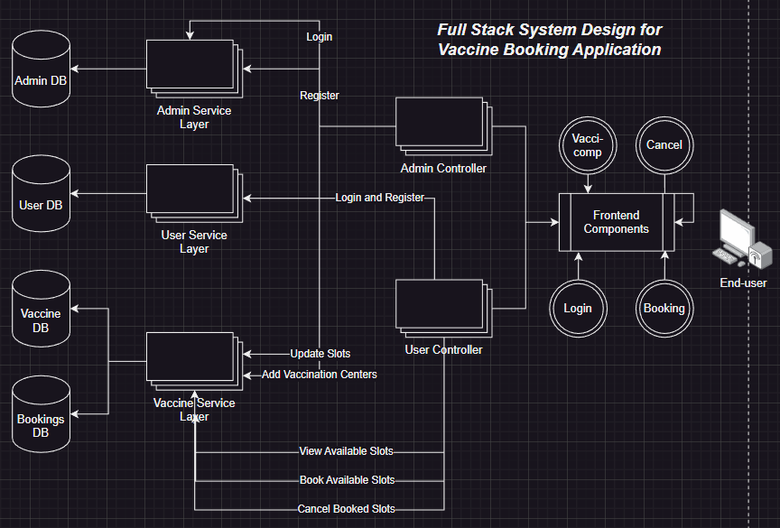

**Happy Path for Admin:**

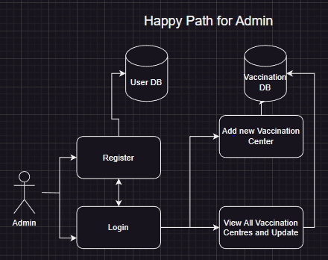

**Happy Path for User:**

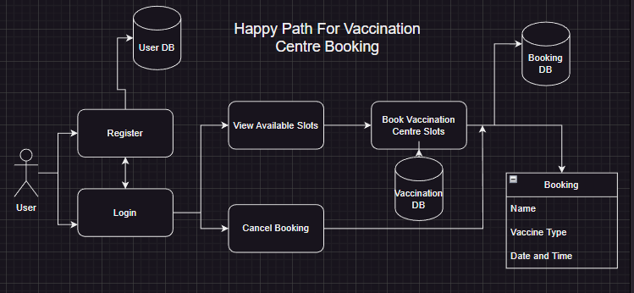

**Application Snapshots:**

